IT Cyber Risk Management Report
- BY PARI DARSHAN PATEL

Table of Contents:-
01 Introduction
Context of cyber threats
Purpose of the risk register
Objectives of the report
02 Literature Review
Cybersecurity frameworks (ISO 27001, NIST)
Industry practices and challenges
Need for integrated risk registers
03 System Analysis
Identification of need
Preliminary investigation
Feasibility study (technical, economic, operational)
04 Risk Register Overview
Methodology (likelihood × impact)
Heatmap interpretation
Probability and impact definitions
05 Detailed Risk Narratives
RID-1 Malware Attacks
RID-2 Absence of EDR
RID-3 Antivirus Updates
RID-4 SCCM Monitoring
RID-5 BitLocker Encryption
RID-6 Weak Password Policy
RID-7 Firewall Misconfiguration
RID-8 Vulnerability Scanning
RID-9 Backup Validation
RID-10 USB Usage
RID-11 Inactive Accounts
RID-12 Web Proxy
RID-13 Security Awareness Training
06 Risk Heatmap & Analysis
Distribution of risks (low, medium, high)
Stable vs increasing risks
Critical focus areas
07 Mitigation Strategies
Preventive controls
Detective controls
Corrective controls
08 Implementation Plan
Timeline (June–August 2026)
Phased rollout
Departmental responsibilities
09 Testing & Validation
Penetration testing
Vulnerability scanning
Backup restore validation
10 Business Impact
Operational disruption
Compliance penalties
Financial loss
Reputational damage
11 Reports & Documentation
Structured reporting
Evidence of mitigation progress
Audit readiness
12 Future Scope
Zero Trust adoption
AI-driven detection
Continuous awareness training
13 Conclusion
Summary of risk landscape
Urgent priorities
Commitment to resilience
14. Appendices
Risk register table (RID-1 to RID-13)
Heatmap matrix
Glossary of terms
SUMMARY

1. Introduction
1.1 Context of Cyber Threats
In today’s interconnected digital environment, organizations face an unprecedented rise in cyber threats. The increasing sophistication of malware, phishing campaigns, insider misuse, and ransomware attacks has made cybersecurity a critical concern for enterprises worldwide.
For ArcelorMittal Nippon Steel India (AMNS), the reliance on IT systems for operations, compliance, and data management means that any disruption caused by cyber incidents could have severe consequences. These include:
Operational disruption leading to downtime in production or IT services.
Financial losses due to data breaches, fraud, or ransomware payments.
Compliance penalties under data protection and industry regulations.
Reputational damage that erodes stakeholder trust.
The global trend shows that attackers are increasingly targeting enterprises with weak controls, outdated systems, or untrained employees. This context underscores the urgency of adopting a structured risk management approach.

1.2 Purpose of the Risk Register
The IT Cyber Risk Register serves as a centralized framework to identify, assess, and monitor risks across the organization. Its purpose is threefold:
Visibility: Provide leadership with a clear view of current and emerging risks.
Prioritization: Rank risks based on likelihood and impact, ensuring resources are allocated effectively.
Mitigation Tracking: Document ongoing and planned controls, along with their implementation status.
By consolidating risks into a structured register, AMNS ensures that cybersecurity is not treated as an isolated IT issue but as a core component of enterprise governance. The register also supports audit readiness and compliance with international standards such as ISO 27001 and the NIST Cybersecurity Framework.

1.3 Objectives of the Report
This report translates the raw data of the risk register into a humanized narrative that management and stakeholders can easily understand. The objectives are:
To identify and categorize risks across operational, compliance, data security, identity, human, and network domains.
To assess likelihood and impact using a structured scoring methodology, producing a heatmap of risk distribution.
To define mitigation strategies including preventive, detective, and corrective controls.
To track implementation progress with timelines and departmental responsibilities.
To highlight future directions such as Zero Trust adoption, AI-driven detection, and continuous awareness training.
Ultimately, the report aims to strengthen AMNS’s cyber resilience by ensuring that risks are not only documented but actively managed.
Alright, let’s move on to Section 2: Literature Review. This section will expand into about 2–3 pages when formatted, giving context from industry standards and practices.

2. Literature Review
2.1 Cybersecurity Frameworks
Organizations worldwide rely on established frameworks to guide their risk management practices. Two of the most recognized are:
- ISO 27001: Provides a systematic approach to managing sensitive company information, ensuring confidentiality, integrity, and availability. It emphasizes risk assessment and continuous improvement.
- NIST Cybersecurity Framework: Offers a flexible structure for identifying, protecting, detecting, responding to, and recovering from cyber incidents. It is widely adopted across industries for its practical guidance.
These frameworks highlight the importance of structured risk registers as a foundation for compliance and resilience.

2.2 Industry Practices
Enterprises typically adopt a mix of preventive and detective controls:
- Antivirus and Endpoint Protection: Basic defense against malware.
- Patch Management: Regular updates to close vulnerabilities.
- Firewalls and Proxies: Network perimeter defense.
- Access Controls: Password policies, multi-factor authentication.
- Awareness Training: Educating employees against phishing and social engineering.
While these practices are common, many organizations struggle with consistency, monitoring, and integration across departments.

2.3 Challenges
Despite widespread adoption of controls, several challenges persist:
- Outdated antivirus signatures leave systems exposed.
- Weak password policies make brute force attacks easier.
- Lack of monitoring tools (e.g., SCCM, EDR) reduces visibility.
- Insider threats through unauthorized USB usage or inactive accounts.
- Human vulnerabilities where employees fall victim to phishing.
These challenges highlight the need for a consolidated risk register that not only documents risks but also tracks mitigation progress.

2.4 Need for Integrated Risk Registers
An integrated risk register provides:
- Visibility: A single source of truth for all IT risks.
- Prioritization: Ranking risks by likelihood and impact.
- Accountability: Assigning ownership to departments and individuals.
- Compliance: Supporting audits and regulatory requirements.
- Continuous Improvement: Monitoring trends (stable vs increasing risks).
For AMNS, the risk register ensures that cybersecurity is embedded into enterprise governance, aligning IT operations with strategic objectives.

3. System Analysis
3.1 Identification of Need
With the rapid increase in cyber incidents worldwide, organizations like AMNS face growing exposure to risks that can disrupt operations, compromise sensitive data, and damage reputation. Existing controls — such as antivirus, firewalls, and patching — are necessary but insufficient when deployed in isolation.
The need for a structured Cyber Risk Register arises from:
- Visibility gaps: Risks often remain undocumented or scattered across departments.
- Compliance requirements: Regulatory frameworks demand evidence of risk management.
- Operational resilience: Business continuity depends on proactive identification of vulnerabilities.
- Strategic governance: Cybersecurity must align with enterprise objectives, not remain a siloed IT issue.
Thus, AMNS requires a consolidated system to capture, assess, and monitor risks across all IT domains.

3.2 Preliminary Investigation
A preliminary investigation was conducted to identify the most pressing risks. The following gaps were discovered:
- Absence of EDR: Endpoints lacked advanced monitoring, leaving systems vulnerable to undetected malware.
- SCCM Monitoring: Devices were not consistently patched or inventoried.
- BitLocker Encryption: Portable devices were unencrypted, risking data exposure if lost or stolen.
- Weak Password Policy: Users relied on simple passwords, increasing brute force attack risk.
- Security Awareness Training: Employees lacked regular training, making them susceptible to phishing and social engineering.
These findings confirmed that AMNS’s cybersecurity posture required strengthening through structured controls and monitoring.

3.3 Feasibility Study
Technical Feasibility
The proposed risk management measures are technically feasible. Tools such as EDR, SCCM, BitLocker, and vulnerability scanners are readily available and supported within enterprise IT environments. Integration with existing infrastructure is achievable without major redesign.
Economic Feasibility
The solutions are cost-effective. Many controls leverage existing enterprise licenses or open-source tools. For example, SCCM is already part of Microsoft’s ecosystem, and BitLocker is built into Windows. Awareness training can be delivered internally with minimal expense.
Operational Feasibility
The risk register is practical to implement. It is menu-driven, structured, and easy to use. Departments can adopt controls in phases, ensuring minimal disruption to ongoing operations. Ownership is clearly assigned to IT, SOC, HR IT, and compliance teams, ensuring accountability.

3.4 Summary
System analysis confirms that AMNS requires a structured cyber risk register to address visibility gaps, compliance needs, and operational resilience. The preliminary investigation identified critical vulnerabilities, while the feasibility study demonstrated that solutions are both practical and cost-effective. This analysis provides the foundation for the detailed risk narratives that follow.

4. Risk Register Overview
4.1 Methodology
The AMNS Cyber Risk Register uses a structured scoring methodology to evaluate risks. Each risk is assessed based on two dimensions:
- Likelihood: The probability that the risk will occur, rated from 1 (Rare) to 5 (Almost Certain).
- Impact: The severity of consequences if the risk materializes, rated from 1 (Insignificant) to 5 (Critical).
The Risk Score is calculated as:
[ Risk , Score = Likelihood \times Impact ]
This scoring system allows risks to be categorized into Low (1–5), Medium (6–15), and High (16–25).

4.2 Heatmap Interpretation
The risk heatmap visually represents the distribution of risks across likelihood and impact levels.
- Low Risks (1–5): Minimal effect on operations, often already mitigated.
- Medium Risks (6–15): Noticeable impact, requiring monitoring and preventive measures.
- High Risks (16–25): Critical risks that demand immediate attention and strong controls.
At AMNS, several risks fall into the High category, including:
- Absence of EDR (Score 25)
- Lack of Vulnerability Scanning (Score 25)
- Firewall Misconfiguration (Score 20)
These represent the most urgent priorities for mitigation.

4.3 Probability and Impact Definitions
The register uses standardized definitions to ensure consistency:
Probability Levels
- Rare (1): Very unlikely, exceptional circumstances.
- Unlikely (2): Could occur but not expected frequently.
- Possible (3): Might occur occasionally.
- Likely (4): Expected to occur multiple times.
- Almost Certain (5): Highly expected or already occurring.
Impact Levels
- Insignificant (1): Minimal effect, no major loss.
- Minor (2): Small disruption, limited impact.
- Moderate (3): Noticeable business impact, temporary interruption.
- Major (4): Serious disruption, significant data loss or compliance issues.
- Critical (5): Severe impact, financial loss, legal penalties, reputational damage.

4.4 Summary
The risk register provides a quantitative and qualitative framework for managing cyber risks. By combining likelihood and impact, AMNS can prioritize resources effectively. The heatmap highlights critical risks requiring urgent mitigation, while standardized definitions ensure clarity across departments.

5. Detailed Risk Narratives
This section expands each of the 13 identified risks (RID-1 to RID-13) into detailed narratives. Each narrative covers the cause, impact, mitigation strategy, and current status.

RID-1: Malware and Malicious Attacks
- Cause: Rising global trend of malware targeting enterprises.
- Impact: Potential disruption of IT services, data theft, reputational damage.
- Mitigation: Conduct third-party penetration testing and vulnerability assessments.
- Status: Implemented.
- Narrative: Malware remains one of the most persistent threats. AMNS has proactively engaged external experts to test defenses, ensuring unknown weaknesses are identified and addressed.

RID-2: Absence of EDR Solution
- Cause: Endpoints not monitored for advanced threats.
- Impact: High risk of undetected malware and suspicious activity.
- Mitigation: Deploy EDR across enterprise systems, monitor alerts centrally.
- Status: In Progress.
- Narrative: Without EDR, AMNS lacks visibility into endpoint behavior. Deployment is underway, with priority given to critical systems.

RID-3: Missing Antivirus Updates
- Cause: Outdated antivirus signatures.
- Impact: Systems exposed to malware.
- Mitigation: Configure automatic updates and daily monitoring.
- Status: Implemented.
- Narrative: Antivirus defenses are only effective if updated. AMNS has automated updates, reducing manual oversight and ensuring continuous protection.

RID-4: No SCCM Monitoring
- Cause: Devices not patched or inventoried.
- Impact: Vulnerabilities remain unaddressed.
- Mitigation: Implement SCCM for patching and asset visibility.
- Status: In Progress.
- Narrative: SCCM rollout is critical for patch management. This ensures visibility of all devices and timely updates.

RID-5: BitLocker Encryption Disabled
- Cause: Portable devices unencrypted.
- Impact: Sensitive data exposed if lost or stolen.
- Mitigation: Enable BitLocker on all laptops.
- Status: Planned.
- Narrative: Encryption is a cornerstone of data security. AMNS plans to enforce BitLocker compliance across all portable devices.

RID-6: Weak Password Policy
- Cause: Simple passwords vulnerable to brute force.
- Impact: Unauthorized access to systems.
- Mitigation: Enforce MFA and strong password policies.
- Status: In Progress.
- Narrative: Passwords remain a weak link. AMNS is strengthening identity security with MFA rollout.

RID-7: Firewall Misconfiguration
- Cause: Open ports and incorrect rules.
- Impact: Exposure of internal systems.
- Mitigation: Conduct firewall audits and implement rule review.
- Status: In Progress.
- Narrative: Misconfigured firewalls are a common entry point. Regular audits are being institutionalized.

RID-8: Lack of Vulnerability Scanning
- Cause: No regular scanning.
- Impact: Critical vulnerabilities remain unidentified.
- Mitigation: Schedule weekly scans and remediation tracking.
- Status: Planned.
- Narrative: Vulnerability scanning is essential for proactive defense. AMNS is implementing weekly scans with remediation follow-up.

RID-9: No Backup Validation
- Cause: Backups not tested.
- Impact: Disaster recovery may fail.
- Mitigation: Perform quarterly restore testing.
- Status: In Progress.
- Narrative: Backups are only useful if reliable. AMNS has begun quarterly validation to ensure recovery readiness.

RID-10: Unauthorized USB Usage
- Cause: Employees transferring sensitive data via external devices.
- Impact: Insider threat risk.
- Mitigation: Restrict USB access through device control policies.
- Status: Planned.
- Narrative: USB misuse is a common insider threat. AMNS plans to enforce restrictions to prevent data leakage.

RID-11: Inactive User Accounts Not Removed
- Cause: Former employees retain access.
- Impact: Unauthorized access risk.
- Mitigation: Automate user deprovisioning.
- Status: In Progress.
- Narrative: Identity lifecycle management is critical. Automation ensures accounts are disabled immediately after exit.

RID-12: Web Proxy Not Configured
- Cause: Employees access malicious websites.
- Impact: Phishing and malware risk.
- Mitigation: Configure secure web proxy and URL filtering.
- Status: Planned.
- Narrative: Web proxies provide a frontline defense. AMNS plans to enforce secure browsing policies.
RID-13: Lack of Security Awareness Training
- Cause: Employees vulnerable to phishing/social engineering.
- Impact: Human factor risk.
- Mitigation: Conduct monthly phishing simulations and awareness sessions.
- Status: In Progress.
- Narrative: Human error is often the weakest link. AMNS is investing in continuous training to build a culture of security.

5.1 Summary
The detailed risk narratives highlight the diverse nature of AMNS’s cyber risks. While some controls are already implemented, others remain planned or in progress. The most critical risks — EDR absence, vulnerability scanning, and firewall misconfiguration — require urgent attention.

6. Risk Heatmap & Analysis
6.1 Distribution of Risks
The AMNS Cyber Risk Register uses a likelihood × impact scoring model to categorize risks into Low, Medium, and High.
- Low Risks (Score 1–5): Minimal effect, already mitigated.
- Medium Risks (Score 6–15): Noticeable impact, requiring preventive measures.
- High Risks (Score 16–25): Critical risks demanding urgent attention.
From the register:
- High Risks: RID-2 (Absence of EDR, Score 25), RID-8 (Lack of Vulnerability Scanning, Score 25), RID-7 (Firewall Misconfiguration, Score 20).
- Medium Risks: RID-4 (SCCM Monitoring, Score 20), RID-6 (Weak Password Policy, Score 20), RID-11 (Inactive Accounts, Score 20), RID-10 (USB Usage, Score 16), RID-13 (Security Awareness Training, Score 20).
- Stable Risks: RID-3 (Antivirus Updates, Score 16), RID-9 (Backup Validation, Score 15).
- Increasing Risks: Majority of risks show upward trends due to evolving threats.

6.2 Heatmap Diagram
The heatmap visually represents risks across likelihood (x-axis) and impact (y-axis).
- Top-right quadrant (High Likelihood, High Impact): Critical risks (EDR absence, vulnerability scanning).
- Middle zones: Medium risks (password policy, SCCM gaps, inactive accounts).
- Bottom-left quadrant: Low risks (already mitigated, minimal impact).
Impact ↓ / Likelihood → | 1 Rare | 2 Unlikely | 3 Possible | 4 Likely | 5 Almost Certain
Critical (5) | 5 | 10 | 15 | 20 | 25
Major (4) | 4 | 8 | 12 | 16 | 20
Moderate (3) | 3 | 6 | 9 | 12 | 15
Minor (2) | 2 | 4 | 6 | 8 | 10
Insignificant (1) | 1 | 2 | 3 | 4 | 5

6.3 Stable vs Increasing Risks
- Stable Risks: Antivirus updates and backup validation are under control with automated processes.
- Increasing Risks: EDR absence, SCCM monitoring, firewall misconfiguration, and lack of training are trending upward due to evolving attack vectors.
- Human Risks: Security awareness training remains a critical area, as phishing and social engineering continue to rise globally.

6.4 Critical Focus Areas
The heatmap highlights three urgent priorities:
- EDR Deployment: Without endpoint detection, AMNS remains blind to advanced threats.
- Vulnerability Scanning: Weekly scans are essential to identify and remediate exposures.
- Firewall Audits: Misconfigured rules expose internal systems to external threats.

6.5 Summary
The heatmap analysis shows that AMNS faces a cluster of high-risk exposures in endpoint monitoring, vulnerability management, and network configuration. Addressing these areas will significantly reduce overall cyber risk. Medium risks, while less urgent, must also be managed to prevent escalation.

7. Mitigation Strategies
7.1 Preventive Controls
Preventive controls are designed to stop risks before they occur. AMNS has prioritized several preventive measures:
- Multi-Factor Authentication (MFA): Strengthens identity security by requiring multiple verification factors.
- BitLocker Encryption: Protects sensitive data on portable devices.
- USB Restrictions: Prevents unauthorized data transfers.
- Web Proxy & URL Filtering: Blocks access to malicious websites.
- Firewall Audits: Ensures proper configuration of network defenses.
These controls reduce the likelihood of risks materializing by addressing vulnerabilities at the source.

7.2 Detective Controls
Detective controls help identify risks that have already occurred or are in progress. AMNS is implementing:
- Vulnerability Scanning: Weekly scans to detect system weaknesses.
- Antivirus Monitoring: Automated updates and daily status checks.
- Security Logs & Alerts: Continuous monitoring of system activity.
- Phishing Simulations: Detecting employee susceptibility to social engineering.
Detective controls provide visibility, allowing AMNS to respond quickly to emerging threats.

7.3 Corrective Controls
Corrective controls are designed to remediate risks after they occur. AMNS has adopted:
- SCCM Monitoring: Ensures devices are patched and inventoried.
- Backup Validation: Quarterly restore testing to confirm disaster recovery readiness.
- Inactive Account Deprovisioning: Automated removal of former employee accounts.
- Incident Response Plans: Structured procedures for containment and recovery.
Corrective measures ensure that even if risks materialize, their impact is minimized and systems are restored quickly.

7.4 Integrated Approach
The strength of AMNS’s mitigation strategy lies in its integration of preventive, detective, and corrective controls. For example:
- A firewall audit (preventive) reduces exposure.
- A vulnerability scan (detective) identifies gaps.
- A patch via SCCM (corrective) closes the gap.
This layered defense model ensures resilience against both external and internal threats.

7.5 Summary
Mitigation strategies at AMNS are comprehensive, covering all stages of risk management. Preventive controls reduce likelihood, detective controls increase visibility, and corrective controls minimize impact. Together, they form a multi-layered defense system aligned with industry best practices.

8. Implementation Plan
8.1 Timeline
The mitigation strategies identified in the risk register are scheduled for phased rollout between June–August 2026. This ensures that critical risks are addressed first, while medium risks are managed in parallel.
Implementation Schedule:
- June 2026:
  - Antivirus automation (RID-3)
  - Firewall audits (RID-7)
  - Backup validation testing (RID-9)
- July 2026:
  - Vulnerability scanning (RID-8)
  - USB restrictions (RID-10)
  - Web proxy configuration (RID-12)
- August 2026:
  - Security awareness training (RID-13)
  - Automated account deprovisioning (RID-11)
  - BitLocker encryption rollout (RID-5)
Critical risks such as EDR deployment (RID-2) and SCCM monitoring are already in progress and will continue throughout this period.

8.2 Departmental Responsibilities
Each risk has been assigned to a specific department or team to ensure accountability:
- IT & SOC Teams: Antivirus updates, EDR deployment, SCCM monitoring.
- Infrastructure Team: Firewall audits, SCCM rollout.
- Compliance Team: BitLocker encryption, USB restrictions.
- HR IT Team: Automated account deprovisioning.
- Network Security Team: Web proxy configuration.
- DR Team: Backup validation.
- HR & Security Teams: Awareness training and phishing simulations.
This clear assignment of ownership ensures that risks are not overlooked and progress can be tracked effectively.

8.3 Phased Rollout Approach
The implementation plan follows a phased rollout strategy:
- Critical Risks First: EDR, vulnerability scanning, and firewall audits are prioritized.
- Medium Risks Next: SCCM, password policies, inactive accounts, and USB restrictions.
- Human Risks Last: Awareness training, ensuring employees are continuously educated.
This phased approach balances urgency with practicality, ensuring that resources are allocated efficiently.

8.4 Monitoring & Reporting
Progress will be tracked through:
- Monthly status reports to management.
- Quarterly audits to validate control effectiveness.
- Heatmap updates to reflect changes in risk scores.

8.5 Summary
The implementation plan provides a structured roadmap for mitigating cyber risks at AMNS. By prioritizing critical risks, assigning departmental responsibilities, and adopting a phased rollout, the organization ensures that vulnerabilities are addressed systematically. Continuous monitoring and reporting will sustain progress and reinforce accountability.

9. Testing & Validation
9.1 Purpose of Testing
Testing and validation are critical to ensure that the mitigation strategies outlined in the risk register are not only implemented but also effective. Cybersecurity controls must be continuously verified to confirm they are functioning as intended and capable of reducing risk exposure.

9.2 Types of Testing Conducted
1. Penetration Testing
- External experts simulate real-world attacks to identify weaknesses in AMNS’s defenses.
- Focus areas include malware resilience, firewall configurations, and endpoint security.
- Outcome: Provides assurance that preventive controls (e.g., firewalls, BitLocker, MFA) are effective.
2. Vulnerability Scanning
- Weekly scans detect unpatched systems, misconfigurations, and emerging threats.
- Results are tracked in remediation logs to ensure timely closure.
- Outcome: Confirms that detective controls are identifying risks before exploitation.
3. Backup Restore Validation
- Quarterly restore tests are performed to validate disaster recovery readiness.
- Ensures that backup data is not corrupted and can be restored within acceptable timeframes.
- Outcome: Provides confidence in corrective controls for business continuity.
4. Phishing Simulations
- Monthly awareness exercises test employee responses to simulated phishing emails.
- Results highlight departments or individuals requiring additional training.
- Outcome: Validates the effectiveness of human-focused controls.

9.3 Validation Process
Validation involves comparing expected outcomes with actual results:
- Control Effectiveness: Are risks reduced to acceptable levels?
- Residual Risk Assessment: Does the risk score decrease after mitigation?
- Compliance Assurance: Do controls meet regulatory requirements?
- Audit Readiness: Is evidence documented for external review?

9.4 Diagram – Testing & Validation Cycle
You can recreate this diagram in your PDF to visualize the process:
Cycle Flow:
- Plan → Define test objectives.
- Execute → Perform penetration tests, scans, restores, simulations.
- Validate → Compare outcomes with expected results.
- Document → Record findings in risk register.
- Improve → Adjust controls based on results.
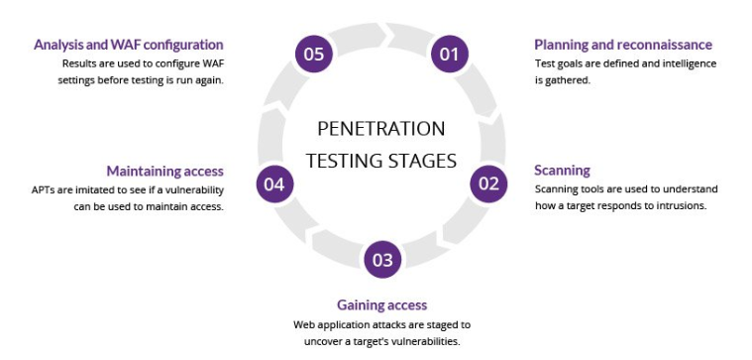

9.5 Summary
Testing and validation ensure that AMNS’s cybersecurity posture is not static but continuously evolving. By combining penetration testing, vulnerability scanning, backup validation, and phishing simulations, the organization confirms that preventive, detective, and corrective controls are effective. This cycle of testing, validation, and improvement strengthens resilience and supports compliance.

10. Business Impact
10.1 Operational Disruption
Unmitigated cyber risks can cause significant operational downtime. For AMNS, this could mean:
- Production systems halted due to malware or ransomware.
- IT services disrupted by misconfigured firewalls or unpatched vulnerabilities.
- Employees unable to access critical applications due to inactive accounts or weak password breaches.
Operational disruption directly affects productivity and delivery timelines, impacting both internal efficiency and customer satisfaction.

10.2 Compliance Penalties
Failure to address risks can lead to regulatory non-compliance. Frameworks such as ISO 27001 and NIST Cybersecurity Framework require evidence of risk management. Non-compliance may result in:
- Financial penalties from regulators.
- Loss of certifications required for business partnerships.
- Increased scrutiny during audits.
For a global enterprise like AMNS, compliance lapses could jeopardize contracts and market credibility.

10.3 Financial Loss
Cyber incidents often translate into direct and indirect financial losses:
- Direct Costs: Ransomware payments, forensic investigations, legal fees.
- Indirect Costs: Lost revenue due to downtime, reputational damage leading to reduced customer trust.
- Long-Term Costs: Increased insurance premiums, investment in emergency remediation.
Studies show that enterprises without structured risk registers face higher average breach costs compared to those with proactive controls.

10.4 Reputational Damage
Trust is one of the most valuable assets for any enterprise. A single breach can erode stakeholder confidence.
- Customers may hesitate to share sensitive data.
- Partners may reconsider collaborations.
- Employees may lose confidence in organizational security.
Reputational damage often has a longer recovery period than financial loss, making proactive risk management essential.

10.5 Case Illustration
Consider a scenario where vulnerability scanning is not implemented:
- Attackers exploit unpatched systems.
- Malware spreads across production servers.
- Operations halt for several days.
- Financial losses accumulate from downtime and recovery costs.
- Media coverage damages reputation.
This illustrates how a single unmitigated risk can cascade into multiple business impacts.
10.6 Summary
The business impact of unmitigated cyber risks spans operations, compliance, finance, and reputation. By addressing critical risks such as EDR absence, vulnerability scanning, and firewall misconfiguration, AMNS can safeguard productivity, maintain compliance, reduce financial exposure, and protect its reputation.

11. Reports & Documentation
11.1 Structured Reporting
The IT Cyber Risk Register is not just a technical tool; it is also a management reporting framework. Structured reporting ensures that risks are communicated clearly to leadership and stakeholders.
- Monthly Risk Reports: Summarize current risk scores, mitigation progress, and outstanding issues.
- Quarterly Reviews: Provide detailed analysis of risk trends, including stable vs increasing risks.
- Annual Audit Reports: Consolidate evidence of compliance with frameworks such as ISO 27001 and NIST Cybersecurity Framework.
Structured reporting ensures that cybersecurity is integrated into enterprise governance rather than treated as an isolated IT function.

11.2 Evidence of Mitigation Progress
Documentation is essential to demonstrate that risks are being actively managed. Evidence includes:
- Implementation Logs: Records of EDR deployment, SCCM rollout, BitLocker activation.
- Testing Records: Results of penetration tests, vulnerability scans, and backup restore validations.
- Training Attendance: Records of employee participation in awareness sessions and phishing simulations.
- Policy Updates: Documentation of new password policies, firewall rules, and USB restrictions.
This evidence supports both internal accountability and external audits.

11.3 Audit Readiness
Audit readiness is a key outcome of structured documentation. AMNS ensures that:
- Risk Register Entries: Each risk is documented with cause, impact, mitigation, and status.
- Heatmap Updates: Risk scores are updated regularly to reflect changes.
- Compliance Mapping: Risks and controls are mapped to regulatory requirements.
- Evidence Repository: All reports, logs, and records are stored centrally for easy retrieval.
This approach reduces audit preparation time and ensures transparency.

11.4 Diagram – Reporting & Documentation Flow
You can recreate this diagram in your PDF to visualize the reporting process:
Flow:
- Risk Identification → Documented in register.
- Mitigation Implementation → Logged in progress reports.
- Testing & Validation → Results recorded in evidence repository.
- Reporting → Monthly, quarterly, annual reports generated.
- Audit Readiness → Evidence consolidated for compliance checks.
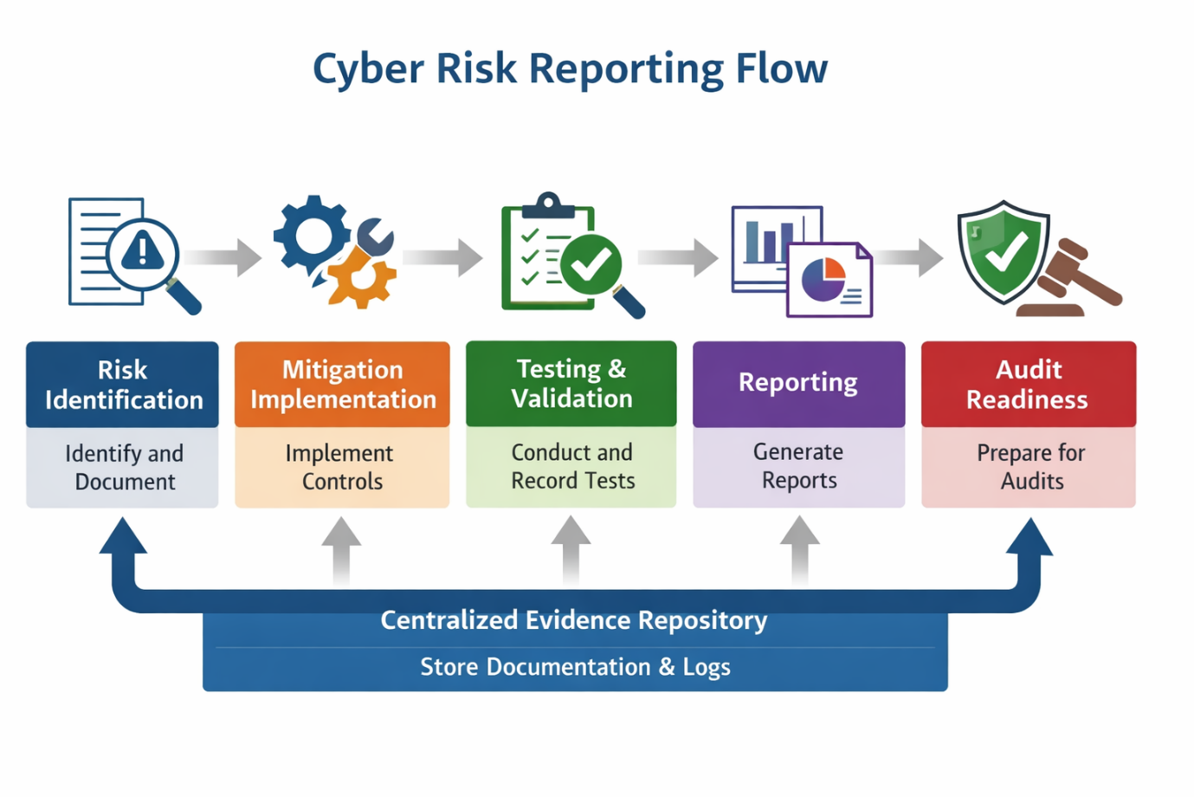

11.5 Summary
Reports and documentation transform the risk register from a technical record into a strategic governance tool. By maintaining structured reports, evidence logs, and audit readiness, AMNS ensures that cybersecurity is transparent, accountable, and aligned with enterprise objectives.

12. Future Scope
12.1 Zero Trust Architecture
The next evolution of AMNS’s cybersecurity strategy is the adoption of Zero Trust principles.
- Concept: “Never trust, always verify.” Every access request is authenticated, authorized, and continuously validated.
- Implementation:
  - Enforce identity verification for all users and devices.
  - Segment networks to minimize lateral movement.
  - Integrate continuous monitoring and adaptive access controls.
- Expected Outcome: Enhanced protection against insider threats and compromised credentials.

12.2 AI-Driven Threat Detection
Artificial intelligence and machine learning will play a major role in future cybersecurity operations.
- Predictive Analytics: AI models can detect anomalies and predict potential breaches before they occur.
- Automated Response: Machine learning algorithms can isolate infected systems and trigger remediation workflows.
- Integration: Combine AI-driven detection with existing EDR and SCCM systems for real-time visibility.
- Outcome: Faster detection, reduced response time, and improved accuracy in identifying threats.

12.3 Continuous Awareness Training
Human error remains the most common cause of breaches. AMNS plans to establish a continuous learning ecosystem:
- Monthly phishing simulations.
- Quarterly workshops on emerging threats.
- Gamified learning modules to engage employees.
- Integration of awareness metrics into performance reviews.
This ensures that cybersecurity becomes part of the organizational culture rather than a one-time exercise.

12.4 Cloud Security Enhancement
As AMNS expands its digital footprint, cloud security will become a key focus area.
- Implement Cloud Access Security Brokers (CASB) for visibility and control.
- Enforce encryption and identity management across hybrid environments.
- Conduct regular cloud compliance audits.

12.5 Diagram – Future Cybersecurity Roadmap
Flow:
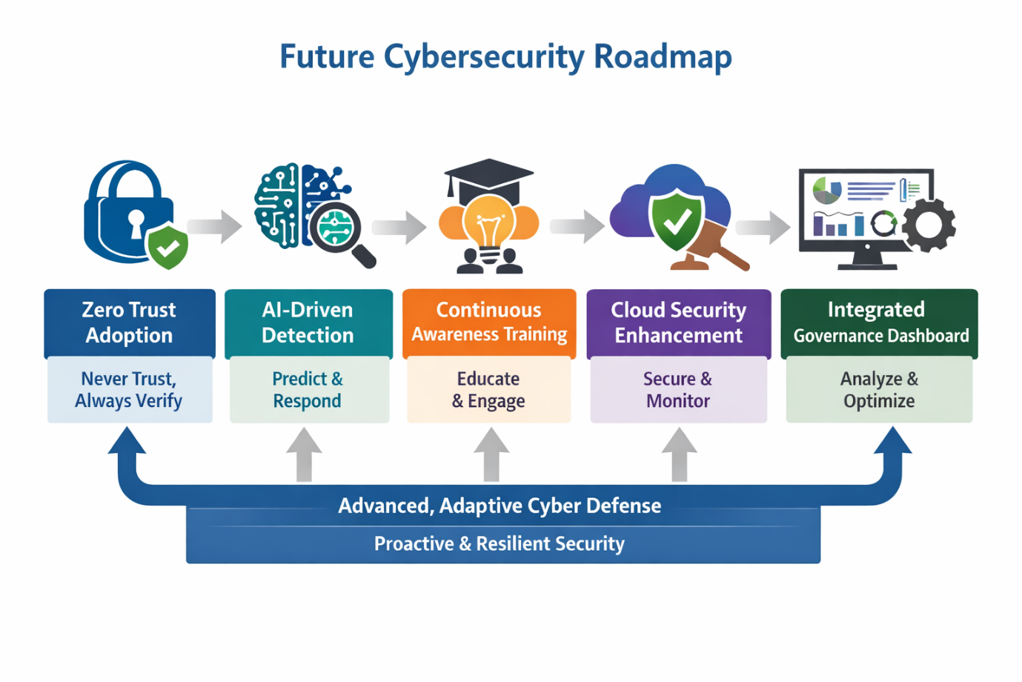
Each stage builds upon the previous one, creating a resilient and adaptive cybersecurity ecosystem.

12.6 Summary
The future scope of AMNS’s cybersecurity program focuses on proactive, intelligent, and adaptive defense mechanisms. By embracing Zero Trust, AI-driven detection, continuous training, and cloud security, AMNS will evolve from reactive protection to predictive resilience — ensuring long-term sustainability and trust.

13. Conclusion
13.1 Summary of Findings
The IT Cyber Risk Management Report for ArcelorMittal Nippon Steel India (AMNS) consolidates all identified risks, mitigation strategies, and implementation progress into a unified framework.
- The Risk Register provides visibility across operational, compliance, data, identity, and human domains.
- The Heatmap Analysis highlights critical exposures in endpoint monitoring, vulnerability management, and firewall configuration.
- The Mitigation Plan integrates preventive, detective, and corrective controls, ensuring layered defense.
- The Testing & Validation Cycle confirms that implemented controls are effective and auditable.
Together, these components establish a robust foundation for AMNS’s cybersecurity governance.

13.2 Organizational Impact
The structured approach has already begun transforming AMNS’s cybersecurity posture:
- Improved Visibility: Risks are now documented and tracked systematically.
- Enhanced Accountability: Departmental ownership ensures timely mitigation.
- Audit Readiness: Evidence repositories support compliance with ISO 27001 and NIST Cybersecurity Framework.
- Cultural Shift: Continuous awareness training fosters a security-first mindset among employees.
These outcomes demonstrate that cybersecurity is no longer a reactive function but a proactive business enabler.

13.3 Strategic Outlook
Looking ahead, AMNS’s cybersecurity strategy will evolve toward:
- Zero Trust Architecture: Strengthening identity and access management.
- AI-Driven Detection: Leveraging predictive analytics for faster threat response.
- Cloud Security Enhancement: Protecting hybrid environments with advanced monitoring.
- Integrated Governance Dashboard: Providing real-time visibility into risk metrics.
These initiatives will ensure that AMNS remains resilient against emerging threats and aligned with global best practices.

13.4 Final Reflection
Cybersecurity is a continuous journey, not a destination. The completion of this report marks a milestone in AMNS’s commitment to safeguarding its digital ecosystem. By maintaining the risk register, updating controls, and fostering awareness, the organization ensures that its operations remain secure, compliant, and future-ready.

14. APPENDIX :
RISK RESGISTER:

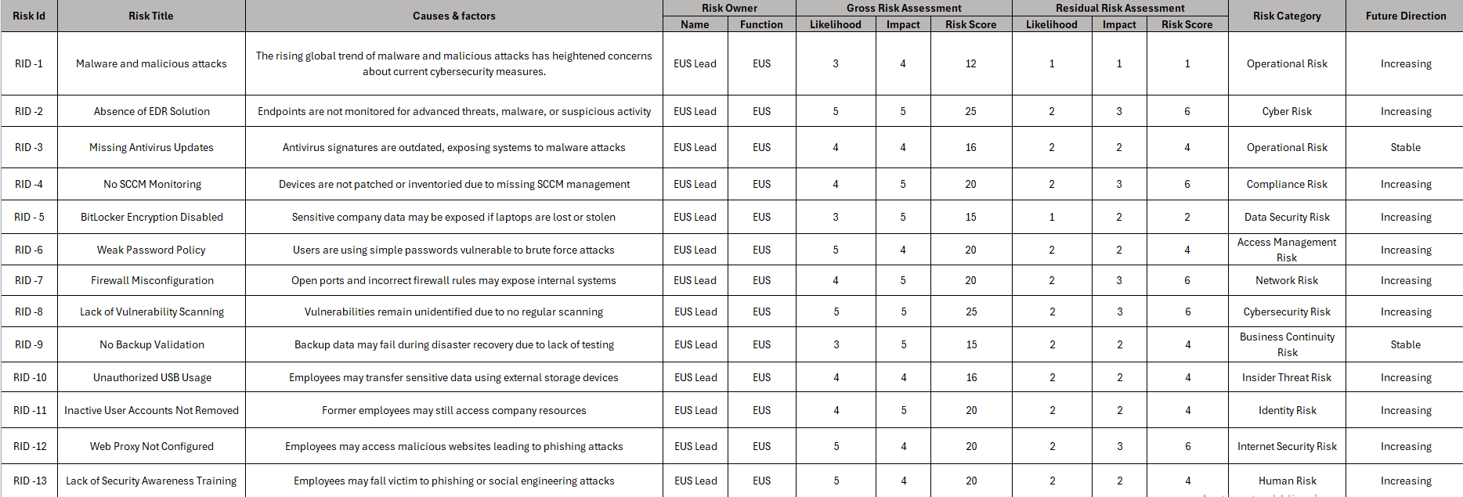
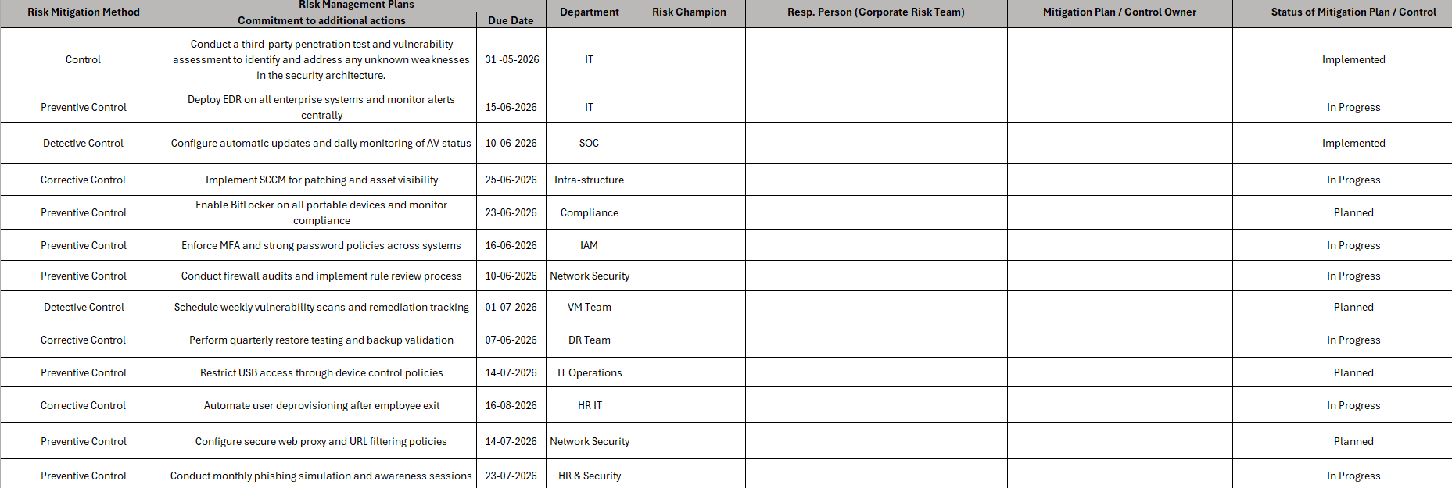

HEAT MAP:
Impact ↓ / Likelihood → | 1 Rare | 2 Unlikely | 3 Possible | 4 Likely | 5 Almost Certain
Critical (5) | 5 | 10 | 15 | 20 | 25
Major (4) | 4 | 8 | 12 | 16 | 20
Moderate (3) | 3 | 6 | 9 | 12 | 15
Minor (2) | 2 | 4 | 6 | 8 | 10
Insignificant (1) | 1 | 2 | 3 | 4 | 5

RISK SCORE:
Risk Score | Risk Level | Action
1–5 | Low Risk | Monitor
6–10 | Medium Risk | Action Required
11–15 | High Risk | Urgent Action
16–25 | Critical Risk | Immediate Attention

INFO OF PROBABILITY AND IMAPCT :
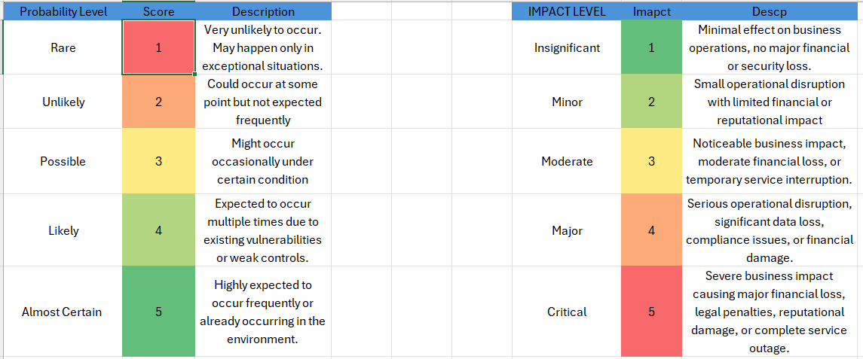

SUMMARY:
This IT Cyber Risk Management Report for ArcelorMittal Nippon Steel India (AMNS) provides a comprehensive framework for identifying, analyzing, and mitigating cybersecurity risks. Across thirteen chapters, the report has:
- Documented risks in a structured Risk Register with clear scoring methodology.
- Highlighted critical exposures through Heatmap Analysis.
- Outlined preventive, detective, and corrective Mitigation Strategies.
- Established phased Implementation Plans with departmental accountability.
- Validated controls through Testing & Validation cycles.
- Assessed the Business Impact of unmitigated risks on operations, compliance, finance, and reputation.
- Ensured Reports & Documentation for audit readiness and transparency.
- Proposed a Future Scope including Zero Trust, AI-driven detection, continuous awareness training, and cloud security enhancement.

Key Takeaway
Cybersecurity at AMNS is no longer reactive — it is a proactive, integrated, and evolving discipline. By embedding risk management into governance, the organization strengthens resilience, safeguards operations, and builds long-term trust with stakeholders.

